**North South University**

**Department of Electrical and Computer Engineering**

**CSE 215L: Programming Language II Lab**

**Lab** – **9: Inheritance**

**Objective:**

* To understand inheritance and its usage
* To learn to utilize inheritance to ensure reusability of existing code

Task:

1. Implement the following classes:

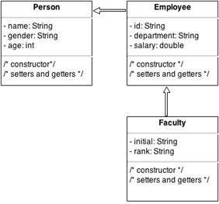

In main method, create a Faculty object and display name, age, salary and initial. Call the toString() method of the Faculty object to display all of its information.

2. Implement the following classes:



Person

* name: String
* age: int
* address: String

 /* constructor, accessor, mutator */

Employee

* department: String
* designation: String

 /* constructor, accessor, mutator */



PartTimeEmployee

* hours: double
* rate: double

/* constructor */

/* accessor-mutator */

/* toString */

+ salary(): double

FullTimeEmployee



* basic: double
* allowance: double

/* constructor */

/* accessor-mutator */

/* toString */

+ salary(): double

The relationship is as follows:

Employee extends Person

PartTimeEmployee extends Employee

FullTimeEmployee extends Employee

Create an object for PartTimeEmployee and FullTimeEmployee and print their salary.

For FullTimeEmployee, basic is the base salary, i.e. 15000.

Allowance is usually provided as percentage, i.e. 25%.

So the total salary of a full time employee = 15000 + 25% of 15000 = 18750